AWS CheatSheet

IAM – control of rotation <https://docs.aws.amazon.com/IAM/latest/UserGuide/access_policies.html>

PassRole permission – allows to pass role to service if trust allows

* **Trust policy** - Trust policies define which principal entities (accounts, users, roles, and federated users) can assume the role. An IAM role is both an identity and a resource that supports resource-based policies. For this reason, you must attach both a trust policy and an identity-based policy to an IAM role. The IAM service supports only one type of resource-based policy called a role trust policy, which is attached to an IAM role.
* permissions boundary - Use a managed policy as the permissions boundary for an IAM entity (user or role). That policy defines the maximum permissions that the identity-based policies can grant to an entity, but does not grant permissions. Permissions boundaries do not define the maximum permissions that a resource-based policy can grant to an entity.
* scope-down policy - restricts users to certain portions of S3 bucket
* endpoint policies
* Service control policies - If you enable all features of AWS organization, then you can apply service control policies (SCPs) to any or all of your accounts. SCPs are specify the maximum permissions for an organization or organizational unit (OU). The SCP limits permissions for entities in member accounts, including each AWS account root user. An explicit deny in any of these policies overrides the allow.
* Policy variables - "Condition": {"StringLike": {"s3:prefix": ["${aws:username}/*"]}}
* Service roles (ie: CodeDeploy, EC2), instance profiles (EC2); can attach EC2 service role to instance profile
* <https://docs.aws.amazon.com/IAM/latest/UserGuide/tutorial_cross-account-with-roles.html>

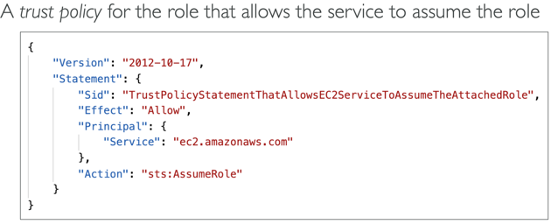 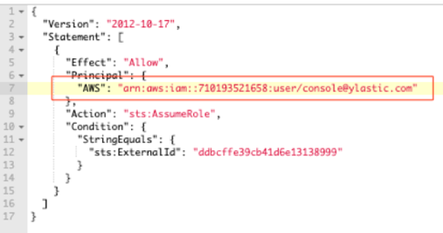

Policies – Managed, Customer, Inline

**Access Advisor feature on IAM console**- identify unused roles

**IAM Access Analyzer** - AWS IAM Access Analyzer helps you identify the resources in your organization and accounts, such as Amazon S3 buckets or IAM roles, that are shared with an external entity. This lets you identify unintended access to your resources and data, which is a security risk.

You can set the scope for the analyzer to an organization or an AWS account. This is your zone of trust. The analyzer scans all of the supported resources within your zone of trust. When Access Analyzer finds a policy that allows access to a resource from outside of your zone of trust, it generates an active finding.

EC2 User Data - Scripts ran are executed as root user

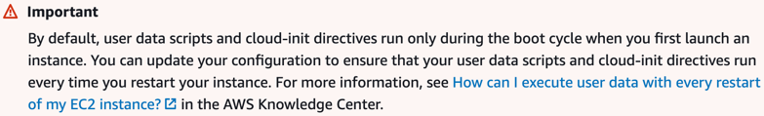

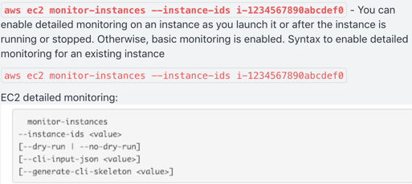 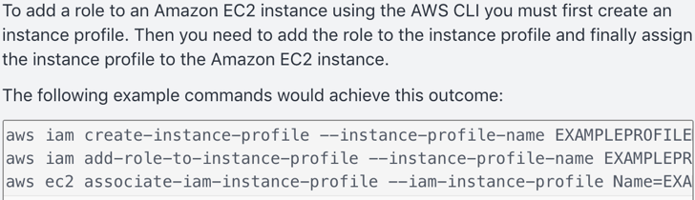

By default basic monitoring is enabled when launching EC2 instance from the console

*\*when EC2 instance is in one security group and RDS instance is in another – if not connecting then open port* ***3306*** *to security group that RDS instance is in so they can talk*

EC2 Instance Type Pricing: <https://aws.amazon.com/ec2/pricing/>

* **On Demand** – predictable pricing by hour, fixed rate, no commitment, for apps w/spiky or unpredictable workloads, highest cost, elastic workloads
* **Savings** – flexible pricing model that offer low prices on EC2, Fargate, Lambda usage in exchange for a commitment to a consistent amount of usage (measured in $/hr) for a 1 or 3 year term
* **Reserved** – 1 or 3 yr contract, provide a capacity reservation making launching instances more reliable, for apps w/steady state usage; excess usage billed at on-demand rate!; zonal or reserved; 2 types:
  + Convertible -
  + Scheduled -
* **Spot** –bid for cheap price, flexible start/end times, urgent computing needs w/ large amounts of additional capacity; not reliable
* **Dedicated** – physical server, useful for regulatory reqs, does NOT support multitenant virtualization, can be purchased on demand (hourly)
* Dedicated Instances run in a VPC on hardware dedicated to a single customer; no control of placement; costs less than Host
* Dedicated Hosts give you additional visibility and control over how instances are placed on a physical server; existing software licenses or regulatory/compliance needs

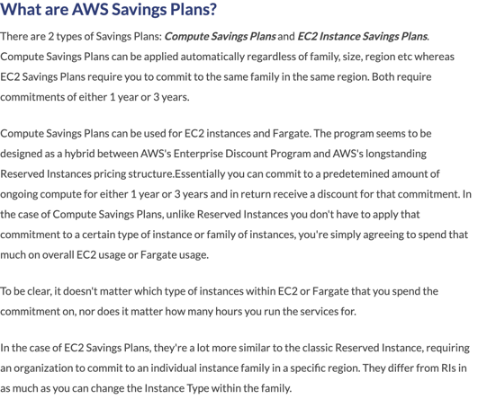

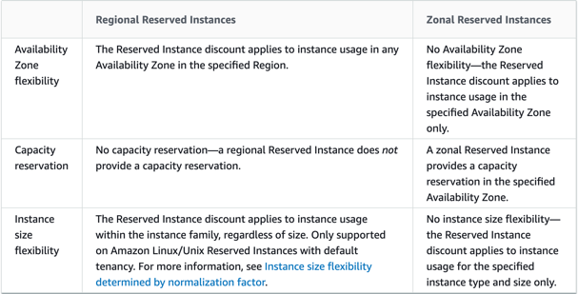 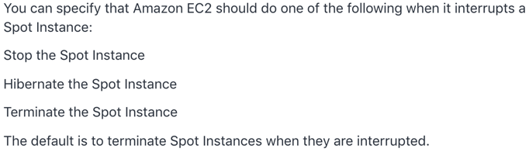

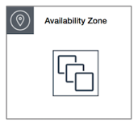 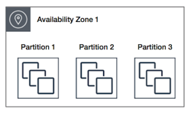 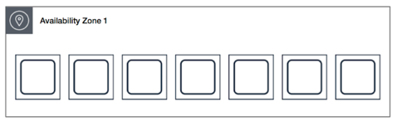

**Cluster** – packs instances close together inside an AZ; low-latency network performance necessary for tightly coupled node-to-node communication

**Partition** – spreads instances across logical partitions such that groups of instances in one partition do not share the underlying hardware with groups of instances in different partitions; typical for large distributed, replicated workloads ie: Hadoop, Cassandra, Kafka

**Spread** – strictly places a small group of instances across distinct underlying hardware to reduce correlated failures

<https://docs.aws.amazon.com/AWSEC2/latest/UserGuide/placement-groups.html>

 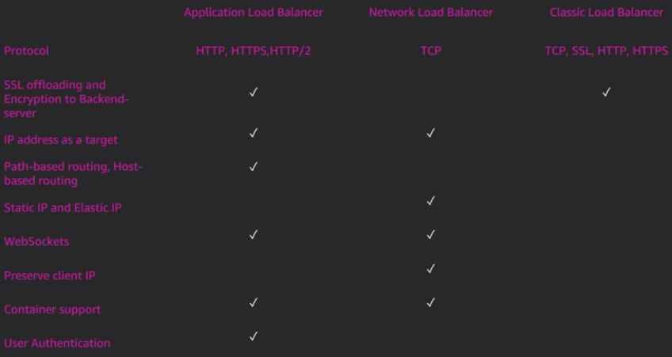

CLB – fixed hostname, Layers 4/7; does NOT support SNI

ALB – **SSL TERMINATION**; HTTP(S), WebSocket, great for redirects (microservices, containers); Layer 7; user auth

NLB –TCP and UDP Layer 4; single static ip per AZ; geo capabilities

* LBs separate public/private traffic; highly available; cross-zone across single region(even distribution); ALB Access Logs can be enabled and capture detailed info (client IP, latency, request path) that is stored encrypted in S3
* <https://docs.aws.amazon.com/elasticloadbalancing/latest/application/load-balancer-monitoring.html>
* Web Application Firewall (WAF); migrating LBs; rules
* Certificate Manager
* **Load Balancer stickiness** is a session feature that instructs the load balancer to route repeated requests to the same EC2 instance whenever possible (avoid reauthenticating when switching pages); must enable cookies; enabled at target group level
* SSL passthrough – forward SSL cert directly to instances resulting in extra processing

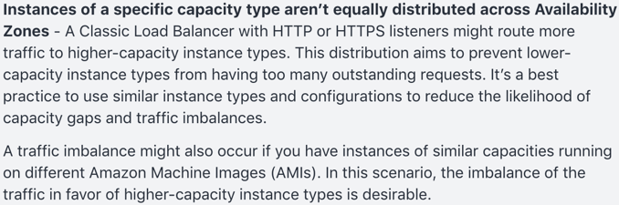 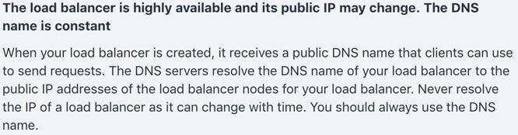

Host and Path based routing

<https://aws.amazon.com/blogs/aws/new-host-based-routing-support-for-aws-application-load-balancers/>

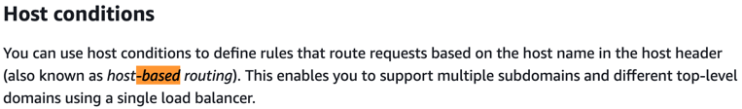 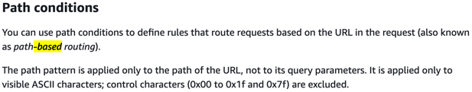

NOTE: **IAM** is used as a certificate manager only when you must support HTTPS connections in a Region that is not supported by ACM. IAM securely encrypts your private keys and stores the encrypted version in IAM SSL certificate storage. IAM supports deploying server certificates in all Regions, but you must obtain your certificate from an external provider for use with AWS. You cannot upload an ACM certificate to IAM. Additionally, you cannot manage your certificates from the IAM Console.

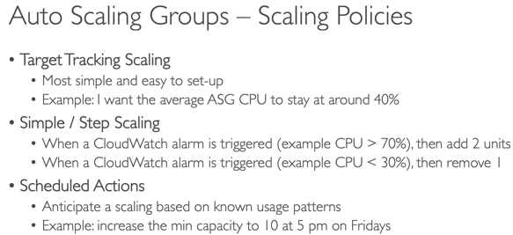 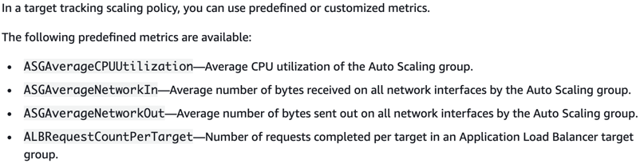

* ASG – lifecycle hooks; launch configuration; mix instance pricing types; does NOT automatically add a new volume when instance is approaching capacity
* By default, the health check configuration of your Auto Scaling group is set as an EC2 type that performs a status check of EC2 instances. To automate the replacement of unhealthy EC2 instances, you must change the health check type of your instance's Auto Scaling group from EC2 to ELB by using a configuration file.
* If the default cooldown period of 300 seconds is too long—you can reduce costs by applying a scaling-specific cooldown period of 180 seconds to the scale-in policy
* If you can’t terminate instances and the AZ rebalances happen then it will run 10% over capacity

EBS Volume Types

**General Purpose SSD (GP2)** – balances price and performance (most popular);

ratio of 3IOPS per GB with *up to 16000 IOPS* and the ability to burst up to 3000 IOPS for extended periods of time for volumes at 3334 GiB and above; 5.3TB max limit

**Provisioned IOPS SSD (IO1)** – designed for I/O intensive apps such as large relational or NoSQL databases; use if you need *more than 16k-64k IOPS*

Magnetic

**Throughput Optimized HDD (ST1)** – streaming, big data, data warehouses, log

processing, cannot be a boot volume

**Cold HDD (SC1)** – lowest cost storage for infrequently accessed workloads; ex: file server, cannot be a boot volume

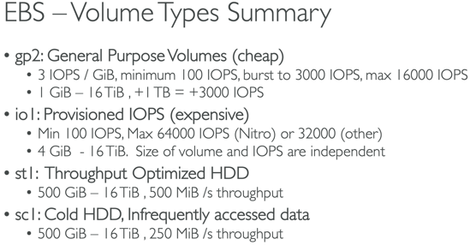

* Locked to an AZ, but can be switched to other instances; deleteOnTermination
* Only GP2 and IO1 can be used as boot volumes
* Can attach multiple EBS to a single EC2 instance
* a volume restored from an encrypted snapshot or a copy of an encrypted snapshot is always encrypted
* encryption by default is a region specific setting
* support for BOTH in-flight and at rest encryption

InstanceStore (very high IOPS, can not increase in size, data loss) and EFS (multi-AZ)

RDS

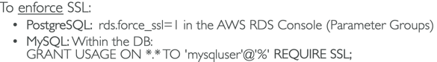 Aurora too

* RDS uses single transaction block for all or nothing (like DDB Transactions)
* RDS automated backups are in a single region
* Aurora Serverless, Aurora Global

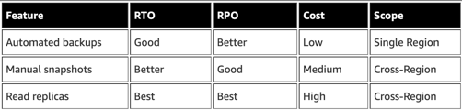 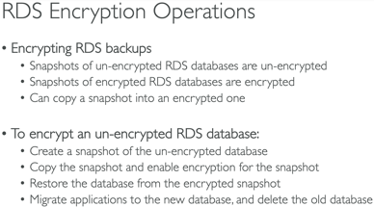

OLTP (simple, frequent) vs OLAP (complex, infrequent, Redshift)

Memcache and Redis

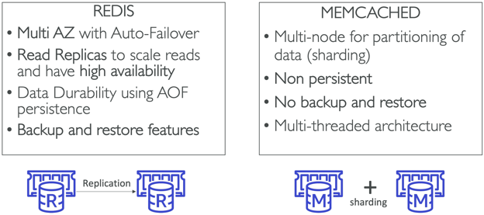

* Redis Cluster Mode – enhance reliability and availability w/little changes to existing workload; horizontal scaling up and down with no performance impact
* Elasticache used to store session data, heavy code changes, makes app stateless

Elasticache vs Read Replicas

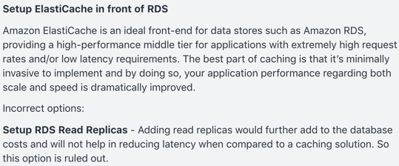 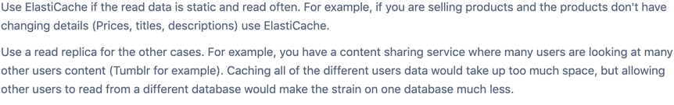

Route 53 Routing policies – simple(hostname->hostname), weighted, latency, failover, geolocation, multi-value(up to 8 records)

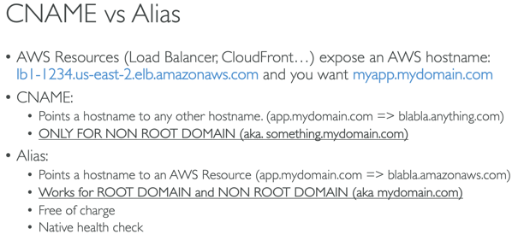 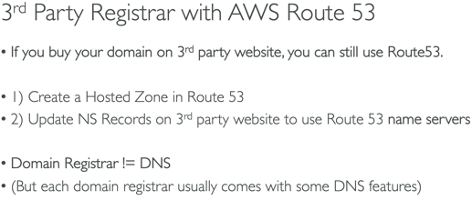

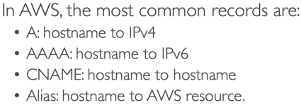

VPC (158-170)

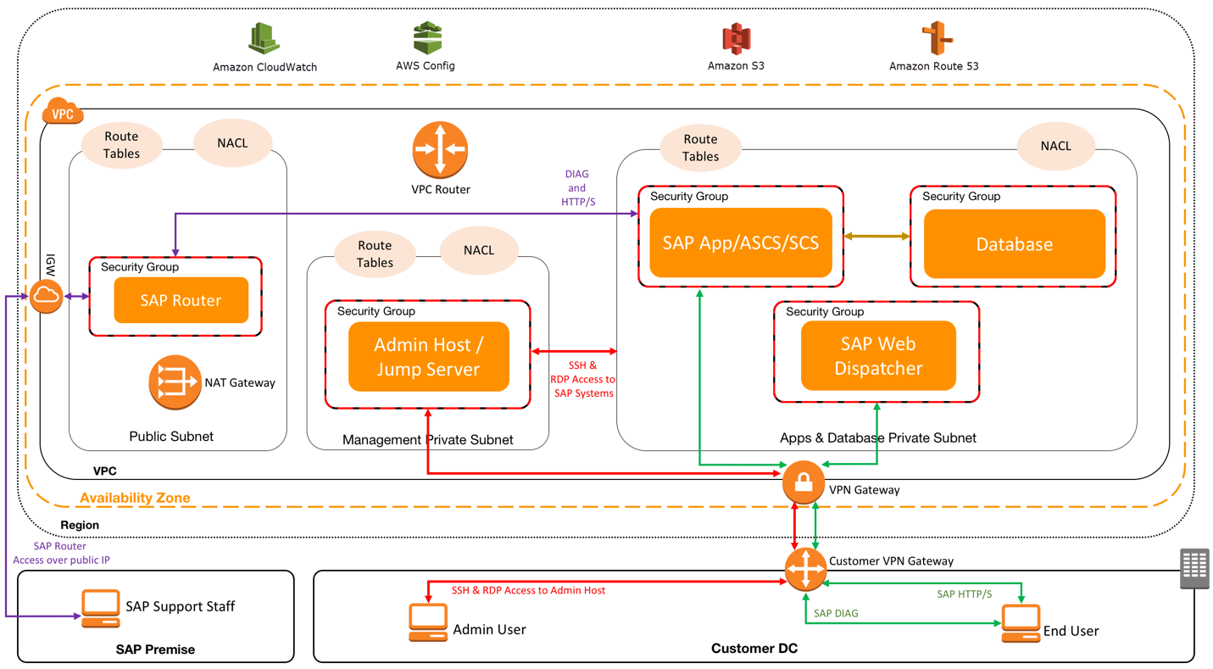

<https://docs.aws.amazon.com/vpc/latest/userguide/VPC_Route_Tables.html>

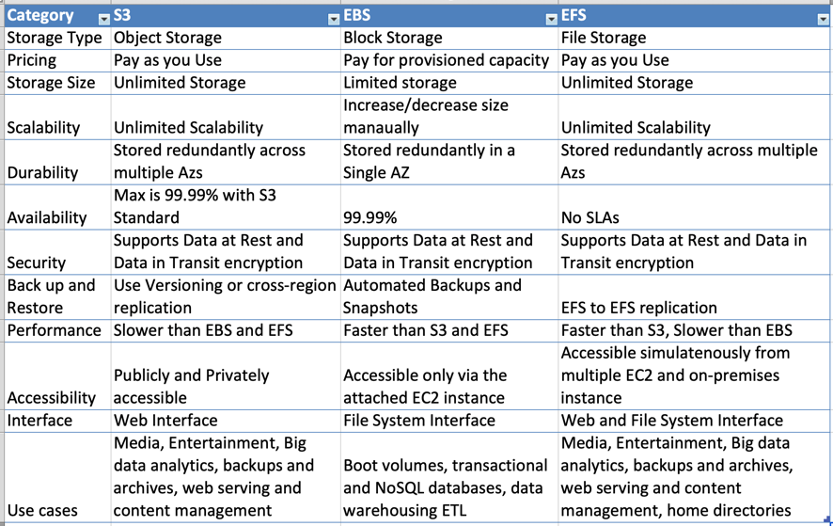

S3 Storage Tiers. <https://aws.amazon.com/s3/storage-classes/>

* S3: 99.(11x9s)% availability/Durability, stored redundantly across multiple devices in multiple facilities and is designed to sustain the loss of 2 facilities concurrently
* S3-IA: infrequently accessed, but requires rapid access when needed; lower fee than S3 but you are charged a retrieval fee
* S3-One Zone IA: same as IA however data is stored in a single AZ only, still 99.(11x9s) durability, but only 99.5% availability; cost is 20% less than regular S3-IA
* Glacier: very cheap, but only used for archival; optimized for data that is infrequently accessed and it takes 3-5 hours to restore from Glacier (each item up to 40TB)
* Glacier Deep Archive
* S3-Intelligent Tiering: unknown/predictable access patterns; 2 tiers (frequent and infrequent); automatically moves your data to most cost-effective tier based on how frequently you access each object; 99.(11x9s) durability; 99.9 availability over year; optimizes cost; no fees for accessing data but a small monthly fee for monitoring/automation $.0025/1k objects; announced Nov 2018
* NOTE: Archives (up to 40TB) stored in Vaults

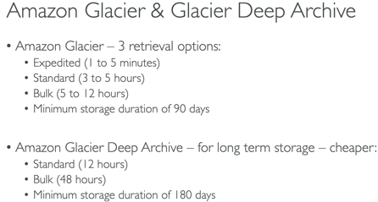 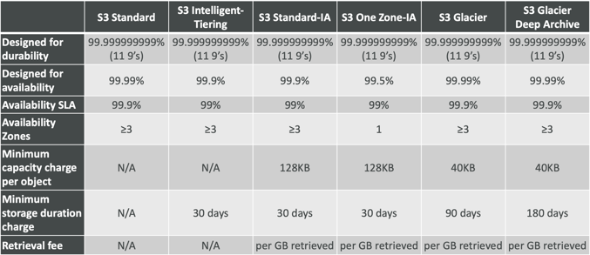

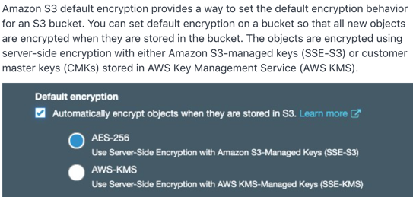 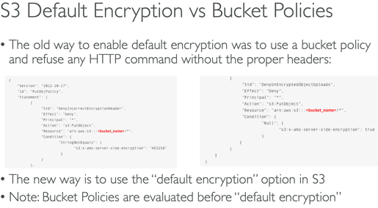

**S3 Object Lock** - S3 Object Lock enables you to store objects using a "Write Once Read Many" (WORM) model. S3 Object Lock can help prevent accidental or inappropriate deletion of data

**S3 Analytics** - By using Amazon S3 analytics Storage Class Analysis you can analyze storage access patterns to help you decide when to transition the right data to the right storage class. You cannot use S3 Analytics to identify unintended access to your S3 resources.

S3 Encryption

* **SSE-S3**: managed, encrypted server side, **AES-256**; must use header ‘x-amz-server-side-encryption:AES256’
* **SSE-KMS**: managed, encrypted server side, user control + audit trail; must use header ‘x-amz-server-side-encryption:**aws:kms**; AWS manages data key, but YOU managed CMK; note – you can manage the rotation policy of CMK with KMS; leverages GenerateDataKey and Decrypt API calls
* **SSE-C**: encrypted server side; keys managed by customer outside of AWS; **HTTPS must be used**; encryption key must be provided in HTTP headers
* **Client Side**: client library such as S3 Encryption SDK; clients must encrypt/decrypt data; customer fully manages the keys

S3: Obj size 0B-5TB; 3500 PUT/5500 GET; multi-part upload over 100MB; transfer acceleration; versioning (must be enabled to ensure a message is sent); if two writes are made to a single non-version object it is possible only 1 event notification sent; **403 error allow for public reads**; MF Delete(must enable versioning) only by bucket owner via CLI; Access Logs; Athena – query files; replication(cross and same region and different accounts); pre-sign urls; lifecycle configuration/rules; SSE-KMS may impact performance; object lock -WORM; S3 Select; ONLY supports standard SQS; to enforce SSL use a bucket policy w/a deny on condition aws:SecureTransport=false

Byte Range Fetches – parallelize GETs by requesting specific byte ranges; speed up downloads

S3/Glacier Select – retrieve less data using SQL by performing server side filtering

<https://docs.aws.amazon.com/AmazonS3/latest/dev/NotificationHowTo.html>

S3 Event can only have one event rule – use Fan Out

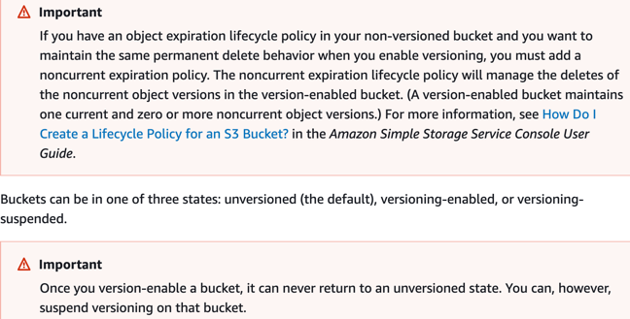 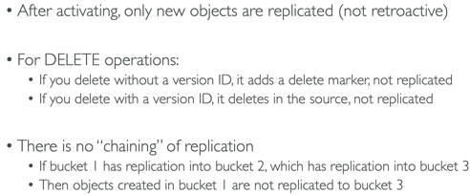

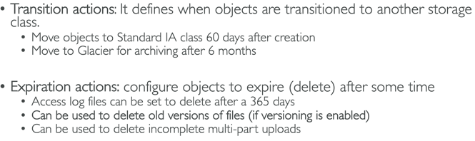

Transfer Acceleration vs CloudFront

S3 Transfer Acceleration optimizes the TCP protocol and adds additional intelligence between the client and the S3 bucket, making S3 Transfer Acceleration a better choice if a higher throughput is desired. If you have objects that are smaller than 1GB or if the data set is less than 1GB in size, you should consider using Amazon CloudFront's PUT/POST commands for optimal performance.

When you create a CloudFront distribution with an origin pointing to your S3 bucket, you enable caching on Edge locations. Consequent requests to the same objects will be served from the Edge cache which is faster for the end user and also reduces the load on your origin. CloudFront is primarily used as a content delivery service.

When you enable S3 Transfer Acceleration for your S3 bucket and use <bucket>.s3-accelerate.amazonaws.com instead of the default S3 endpoint, the transfers are performed via the same Edge locations, but the network path is optimized for long-distance large-object uploads. Extra resources and optimizations are used to achieve higher throughput. No caching on Edge locations.

s3://my-bucket/my_folder1/another_folder/my_file.txt

<http://bucket-name.s3-website.Region.amazonaws.com>

<https://aws.amazon.com/premiumsupport/knowledge-center/cross-account-access-s3/>

S3 object key example - Development/Projects.xls

Data Consistency Model for S3

* **Read after Write consistency** for PUTS of new Objects (immediately available to see)
* **Eventual Consistency** for overwrite PUTS and DELETES (can take some time to propagate)

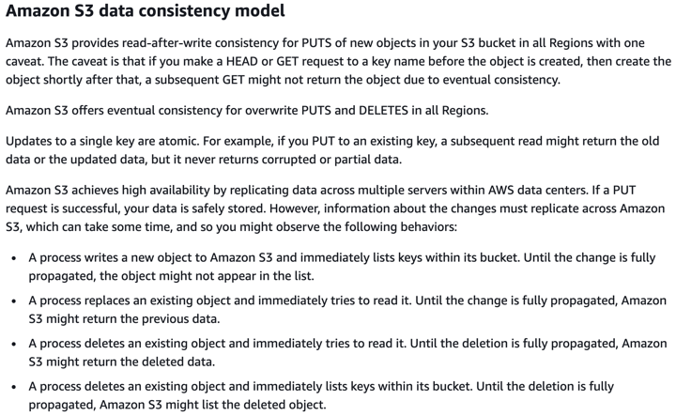 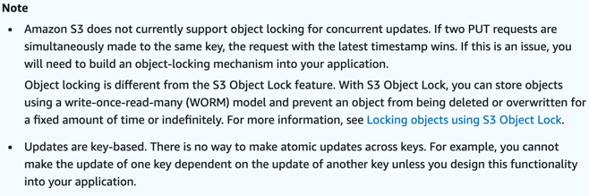

CloudFront – origins – S3, ALB, EC2, any HTTP backend; geo restrictions; caching at Edge; TTL; CreateInvalidation API; maximize cache hit by separating static and dynamic distributions

OAI – user identity used by CF to access S3

CF – great for static content that must be available everywhere

S3 Cross Region Replication – great for dynamic content at low latency in few regions

**CF Signed Cookies, CF Signed URLs and CF Origin Access Identity are all options that allow users to have secure access to private files located in S3.**

**S3 Pre-Signed URL** – issue request as person who pre-signed; uses IAM key; limited lifetime

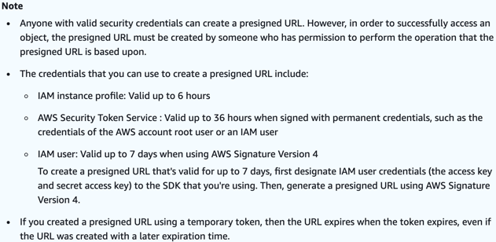 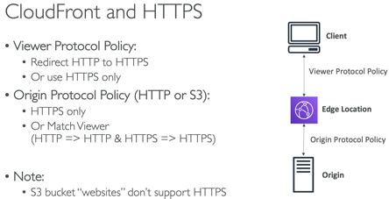

ECS/ECR/Fargate (263-293)

/etc/ecs/ecs.config -> ECS_CLUSTER

Fargate – charged per running Task

**ECS_ENABLE_TASK_IAM_ROLE** – enables IAM role for tasks for containers w/ bridge and default network modes

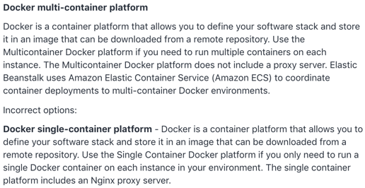

If you terminate a container instance in RUNNING state, that container instance is automatically removed, or deregistered, from the cluster. However, if you terminate a container instance in STOPPED state, that container instance isn't automatically removed from the cluster.

Task placement strategies: binpack, random, spread

Only specify container port – not host port; use ALB for dynamic port mapping

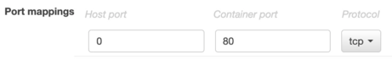

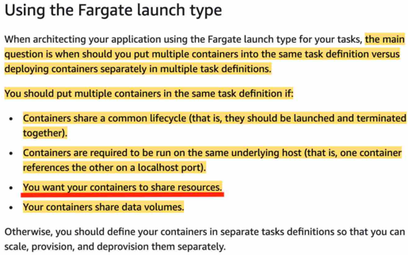

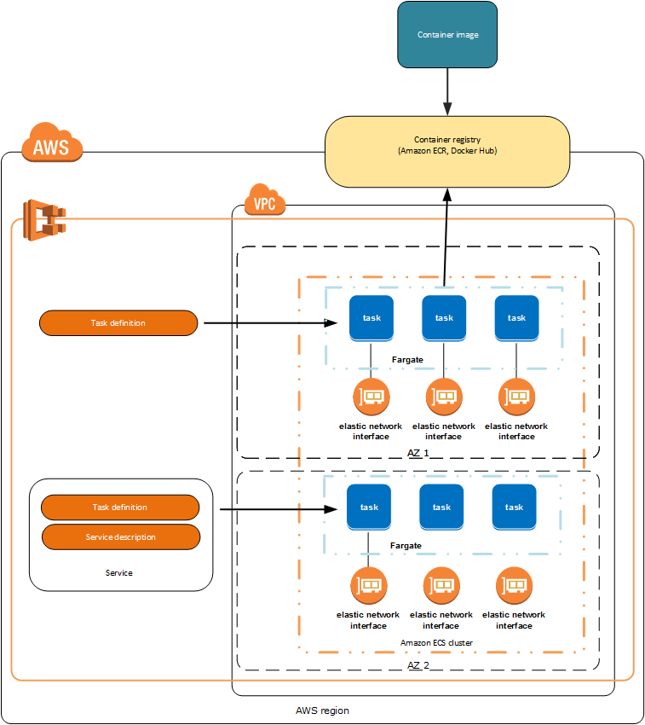 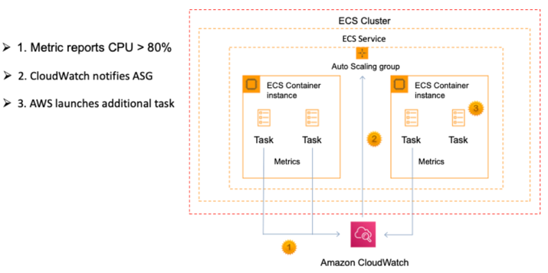

You can run an ALB with an ECS service in an ASG

CodePipeline stores artifacts in S3

CodeCommit IAM supported credentials – Git creds(HTTPS), SSH keys, AWS access keys

CodeCommit is auto encrypted at rest AND in transit

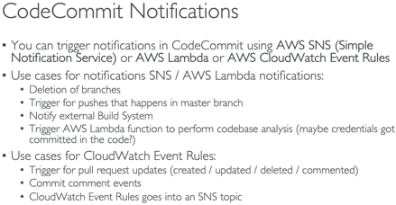

CodePipeline does not trigger Lambda functions directly

Deployments

* ElasticBeanstalk /.ebextenstions/<custom>.config (yml/json); dockerrun.aws.json to generate ECS task definition; (All at Once, Rolling, Rolling w/batch, Immutable); need a ./ebextensions/xray-daemon.config file for Xray; env vars(limit 4096 bytes); use another file with dependencies to zip; env cloning; worker env – cron.yaml; resources created as part of ebextenstions will be deleted if environment is terminated
* CloudFormation Template (yml/json); stacks, templates in S3; output values can be imported if exported first!; can’t delete stack if outputs being referenced by another stack – must delete stacks with imports first; can not create cross stack references across regions; export values must be unique w/in region; Ref – references params and resources
* SAM – extension of CF, build, package and deploy (yml); requires Transform/Resources sections; export names must be unique within a region
* **CodeDeploy** – appspec.yml (In Place or Blue/Green); Lambda/ECS can only use B/G; CodeDeploy Agent; for EC2, onpremise or Lambda; does NOT provision resources
* **CodeBuild** – buildspec.yml (must be at root); cache dependencies in S3 (or in source code during last stage); you can leverage SSM Parameter Store to store large numbers of env variables; use CodeBuild Agent test locally; build env uploads logs to S3; env vars; phases – install, pre, build, post; specify vpc config to access resources in vpc; capability to set timeouts; scales automatically

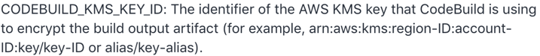

Rollbacks

**CodeDeploy** – auto and manual rollbacks; rolls back deployments by redeploying a previously deployed revision of an app as a new deployment on the failed instances FIRST

**CloudFormation** – creation: rollback entire stack (default) - option to disable;

-update: rollback to last working state;

delete all of the imports before the exports

EB – rollback to previous version

ChangeSets – list changes to be made when you update a stack

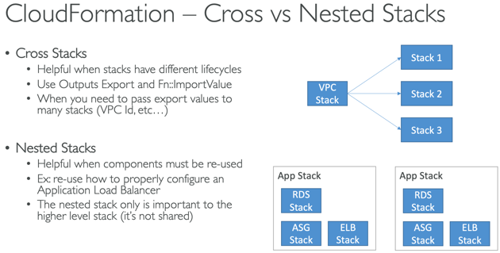 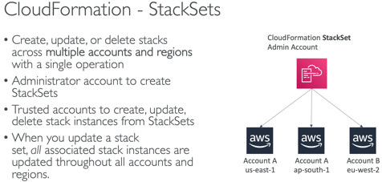

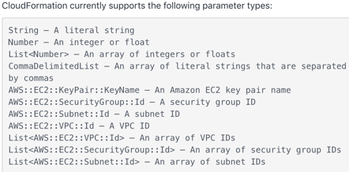

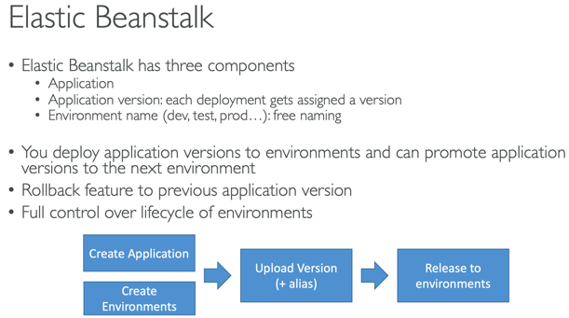 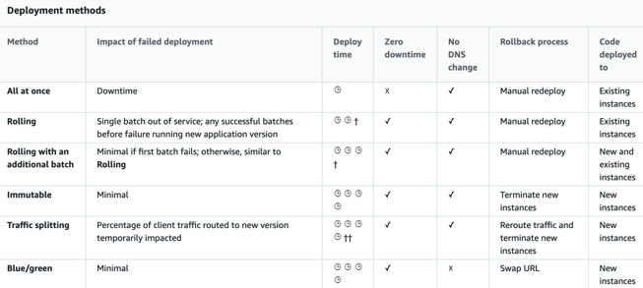

EB- Upload zip file and add new version (up to 1k versions – use lifecycle policy); env variables

Best practice: Define a dev environment with a single instance and a ‘load test’ env that has settings close to prod. You can have multiple environments for the same application.

NOTE: to allow EC2 instances in EB env to connect to outside db there are two additional config steps required – **additional Security Group added to your environment’s Auto Scaling group, you’ll need to provide connection string config info to your app servers**

<https://aws.amazon.com/premiumsupport/knowledge-center/elastic-beanstalk-migration-accounts/>



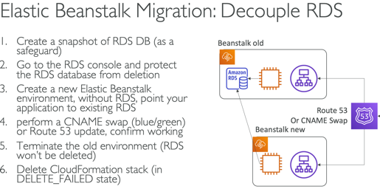 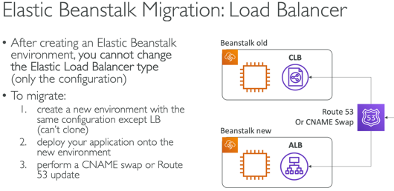

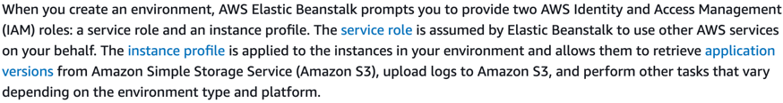

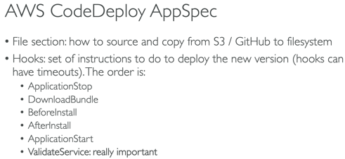 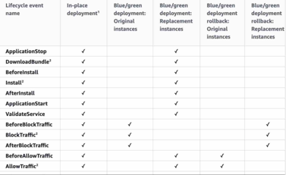

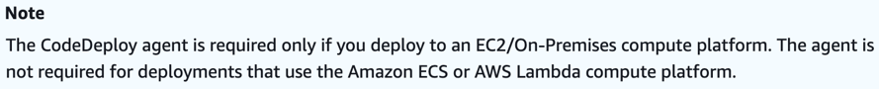

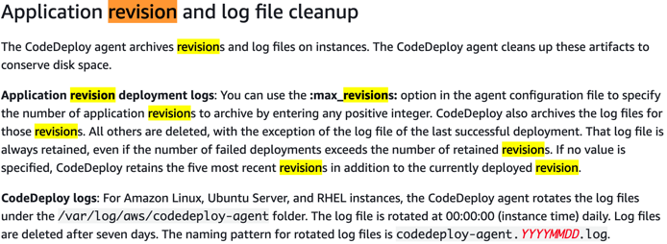 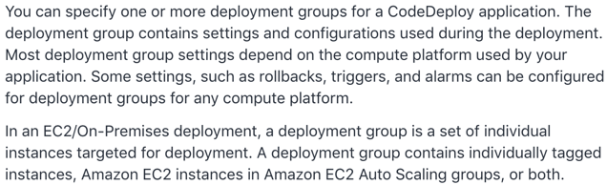

SAM Policy Templates:

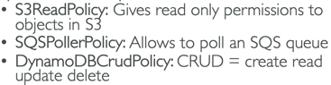

* SAM uses CodeDeploy to update Lambda aliases

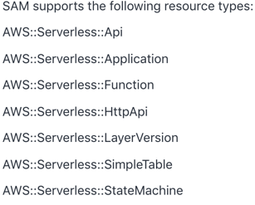 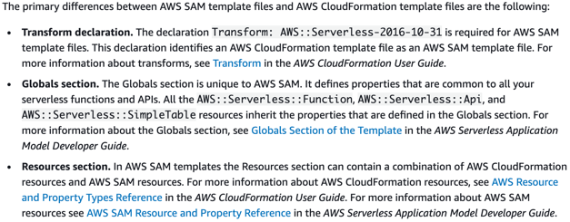

<https://docs.aws.amazon.com/AWSCloudFormation/latest/UserGuide/intrinsic-function-reference.html>

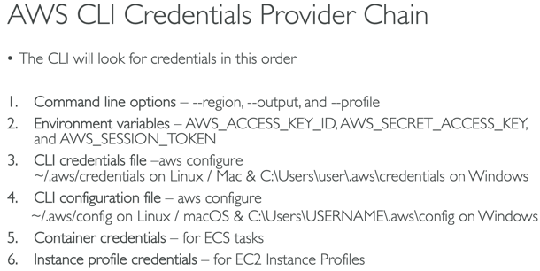 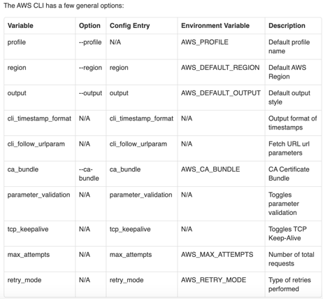

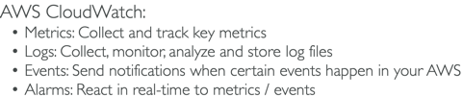 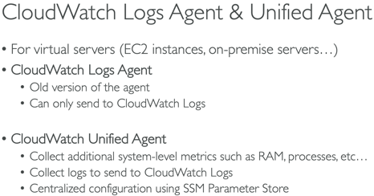 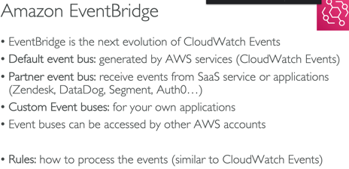

CloudWatch Events - Triggers to Lambda functions, SQS/SNS/Kinesis Messages

EventBridge – Schema Registry; default, partner and custom event buses; cron events

CloudWatch Logs – architecture – Log group(app) and stream(instances w/in app); KMS encryption at group level; cannot use the console must use associate-kms-key if log group already exists or create-log-group; filters not retroactive

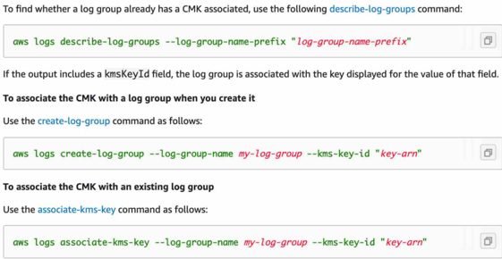

The Amazon CloudWatch Agent can be configured to stream logs and metrics to CloudWatch. Metric filters can be created from logs stored in CloudWatch Logs.

CloudWatch Custom Metrics – StorageResolution API - 1 sec, 1 min; PutMetricData API

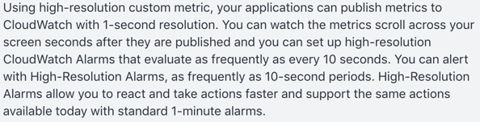 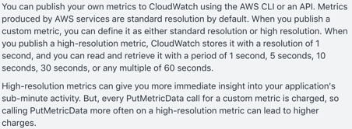

CloudTrail – user activity logging

CloudTrail event logs **CreateVolume** aren't available for EBS volumes created during an EC2 launch.

CloudTrail trails – one or all regions; delivers events to specified S3 bucket; organization trail for all accounts in AWS Orgs – must be created by master acct and members can see the trail but will not have access to logs <https://docs.aws.amazon.com/awscloudtrail/latest/userguide/how-cloudtrail-works.html>

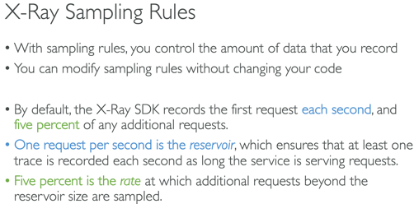 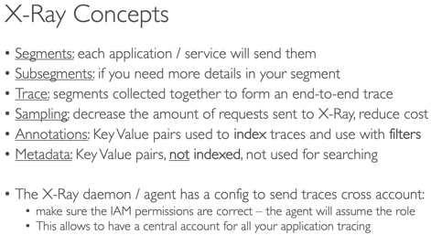 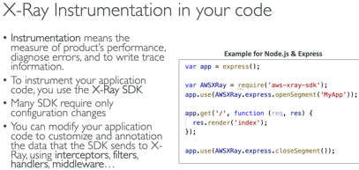

Running X-Ray daemon for Docker containers on Fargate requires a task role for the container AND deploying the daemon agent as a sidecar container

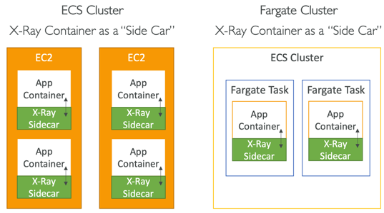 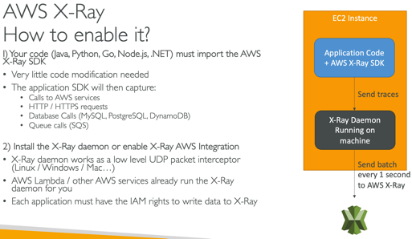 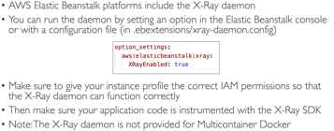

X-Ray can collect data across accounts

SQS: unlimited throughput/messages; highly scalable; 120k max inflight, 1min, 4 days(default), 14 days; 256kb/message sent (use Extended Client w/S3); poll up to 10; default message visibility timeout 30 sec/max 12 hr; scales automatically based on demand (ie: high demand on Black Friday)

DLQ, Delay Queue (0 sec – 15min DelaySeconds), Long Polling(1-20sec WaitTimeSeconds); deduplication; message grouping w/producer unique MessageGroupID; Standard; FIFO(3k/s w/batch, 300 w/o); FIFO only one consumer if no group ids

You can create two SQS queues – one for premium members and one for free members; Program your EC2 fleet to poll the premium queue first and, if empty, to then poll your free members SQS queue.

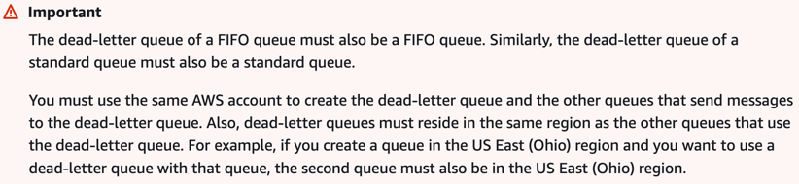 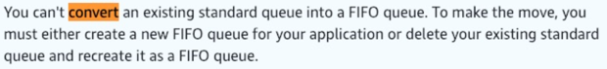

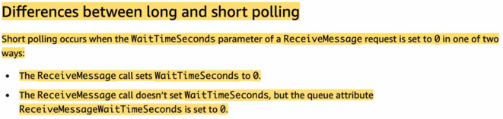 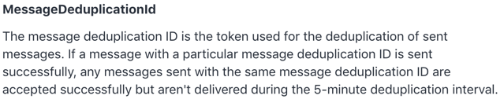

* SNS (and S3) can’t send to SQS FIFO

SQS/SNS/Kinesis Encryption – inflight, KMS/server, Client side; use Batching to decrease costs and increase throughput

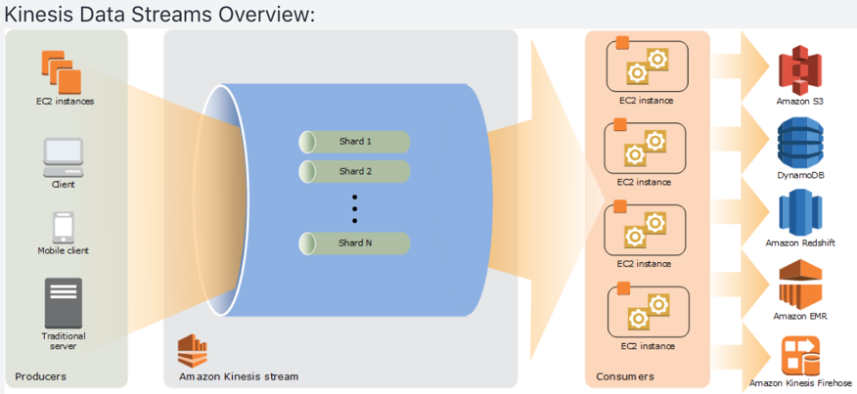

Kinesis Streams – shards, data retention 7 day max (default 1); multiple apps can consume same stream; records ordered/shard; 1MB/1k messages at write per shard – 2MB at read; partition key hashing; hot partition; batching;

provisionthroughputexceeded – retry w/backoff, increase shards, ensure no hot partition, batch messages; control access and auth using IAM policies

Analytics – real time queries, sql

FireHose – near real time, load data to Redshift, S3, ES, Splunk

KCLs – share read workload; each shard read by ONLY 1 KCL instance; partition keys; hot partition; run on EC2, on prem and Beanstalk

* SQS group data with Group ID, Kinesis with partition key
* **NOTE: SNS protocols: HTTP(s), Email, Email-JSON, SQS, SMS**

Kinesis Enhanced Fanout:

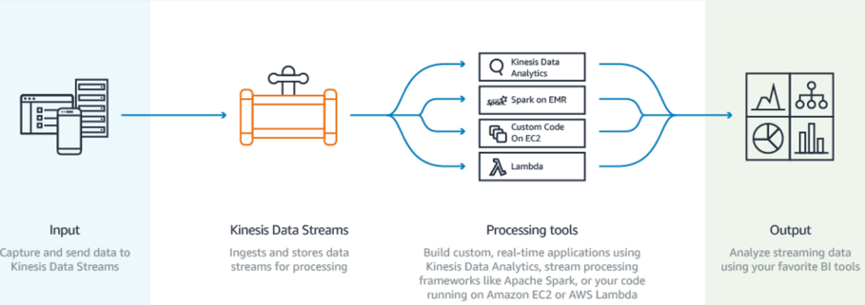 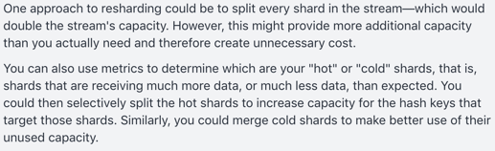

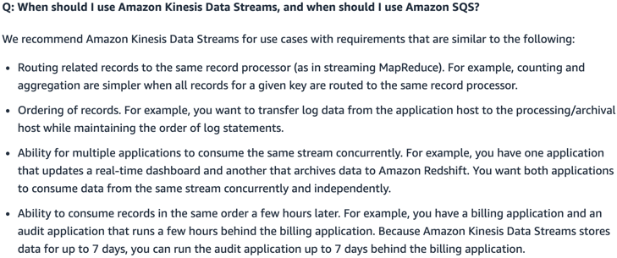 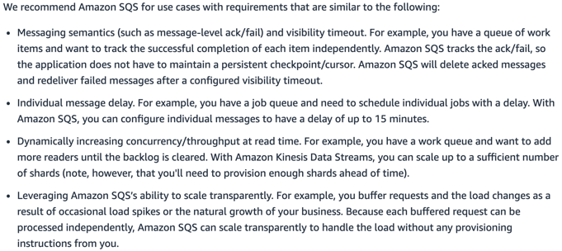

Lambda

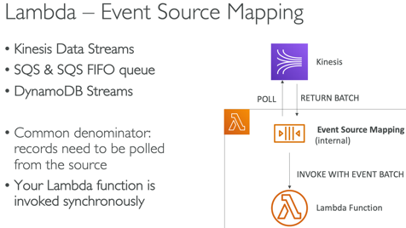

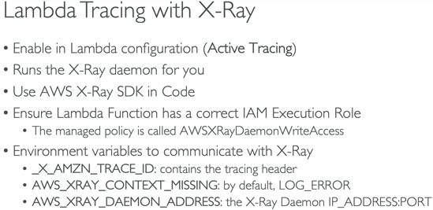 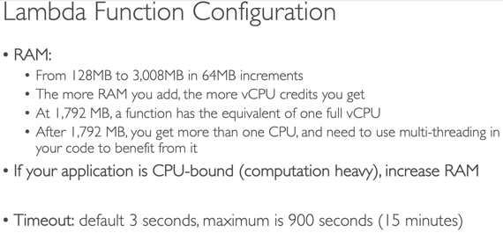

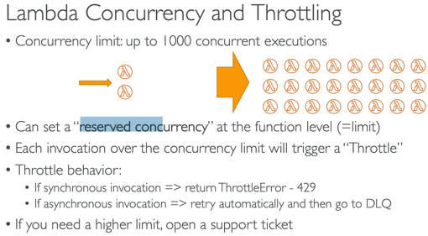 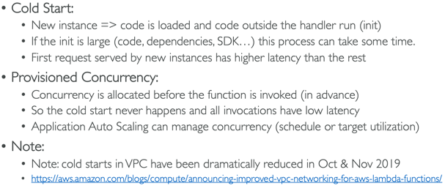

* Provisioned concurrency is ideal for spike in traffic to allow scaling w/o fluctuations in latency
* <https://docs.aws.amazon.com/lambda/latest/dg/configuration-concurrency.html>

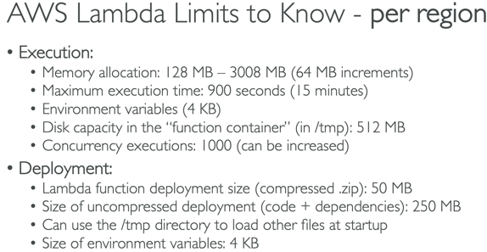 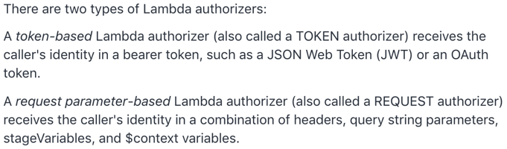

* Up to 3GB of RAM - 'Error: Memory Size: xxxx MB Max Memory Used'
* Env vars should not exceed 4KB – no limit on number of vars
* Can be registered as target for ALB
* Lambda@Edge – global, can change CF requests/responses
* Docker is not for Lambda, its for ECS/Fargate
* AWSLambdaVPCAccessExecutionRole (521-523)
* If Lambda needs to download big file or needs disk space use **/tmp directory** (max 512MB); for permanent persistence use S3 or DDB
* Concurrency limit – 1k concurrent executions
* External libraries – install packages alongside code and zip together **(<50MB**)
* CF – code can be inline Code.ZipFile or zipped on S3 and referenced
* Package Limit – 50MB compressed/250 uncompressed else upload to S3
* use Layers for external dependencies; layers and function can’t exceed package size limit
* Function can use up to 5 layers at a time
* Alias point to versions
* A lambda function that takes 20 sec to execute and executes 20x will take 400 concurrent executions
* Invocation (read) and Execution(what it can do) Role
* Use Destinations(SQS, SNS) over DLQ
* When you use an event source mapping to invoke your function, Lambda uses the execution role to read event data
* <https://aws.amazon.com/premiumsupport/knowledge-center/lambda-function-assume-iam-role/>
* <https://docs.aws.amazon.com/lambda/latest/dg/invocation-async.html>

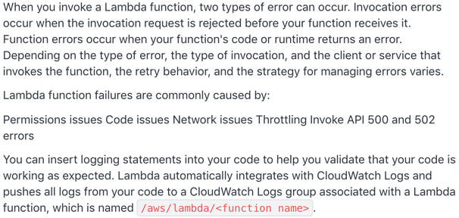

DynamoDb

* Max size item/row 400kb
* Default uses Eventually Consistent Read(may include stale data), but GetItem, Query and Scan have ConsistentRead parameter (most up to date data)
* Query and Scan return 1MB – use pagination to keep reading
* Hot partition; adaptive capacity – enables DDB to run imbalanced workloads indefinitely, auto enabled, continue to read/write to hot partition w/o being throttled
* 5min default for TTL on DAX (solves hot key)
* DB Streams – 24 hr data retention; cross region replication
* Optimistic concurrency with locking during writes
* GSI – eventually consistent, if writes are throttled on GSI then main table will be throttled too; LSI – strongly consistent; max 5/table
* **Transactions** API for ACID actions; CRUD operations on multiple tables at same time; all or nothing
* 1 WCU = 1 write/sec x 1KB; 1 RCU = 1 strongly/2 eventually consistent/sec x 4KB
* 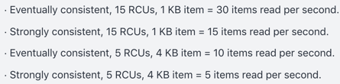
* Can NOT attach resource policy
* default is ascending order
* reverse the order by setting the **ScanIndexForward** parameter to false
* To improve performance reduce the page size (ie: only return 20 items)
* To improve scan performance configure DynamoDB to use Parallel scans instead by dividing a table/index into segments and scanning each segment in parallel; best to avoid parallel scans if your table/index is already incurring heavy read/write activity from other apps
* **BatchGetItem** retrieves multiple items from database
* DynamoDB Stream logs encrypted and stored for **24 hrs**

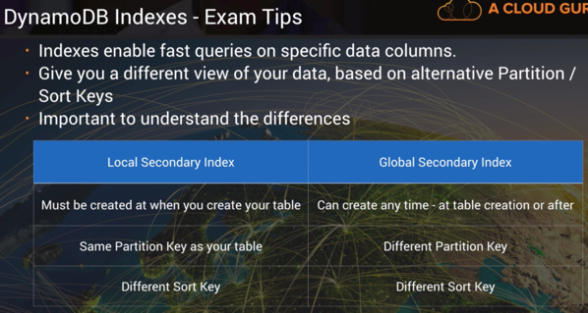 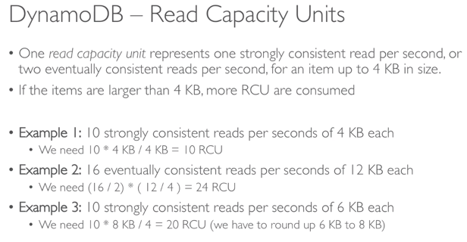

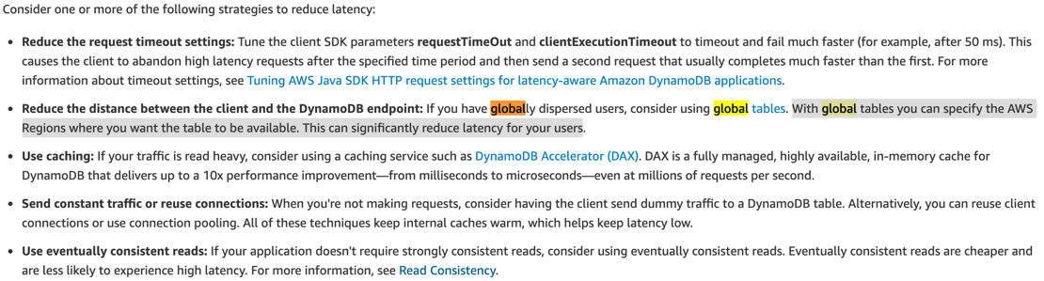

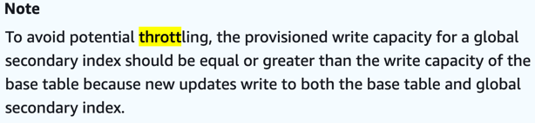 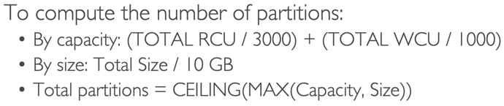

GSI likely to be throttled compared to LSI

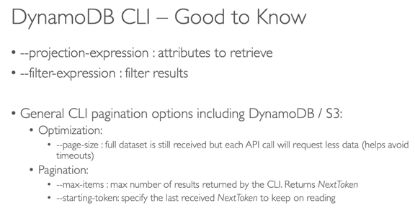 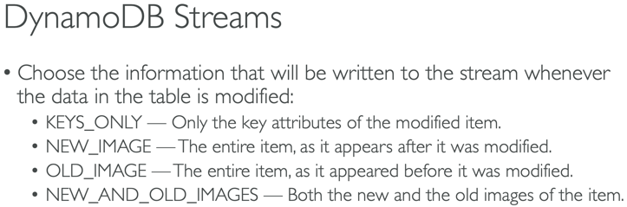

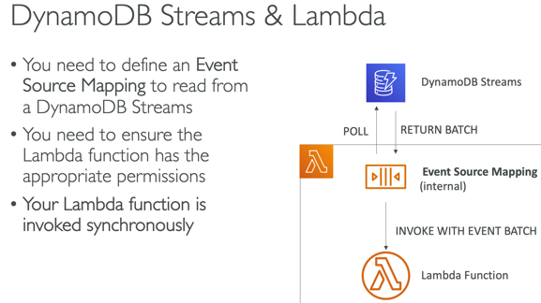 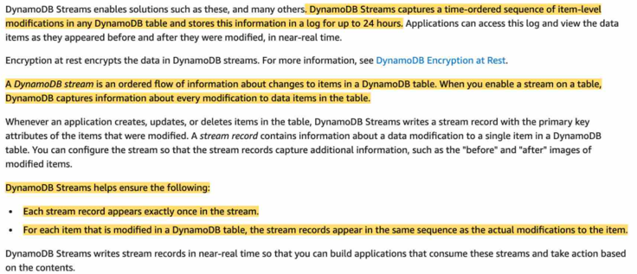

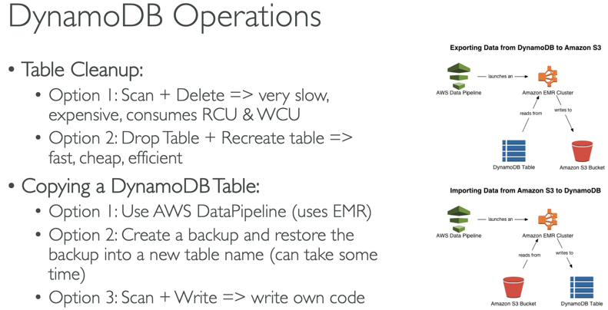 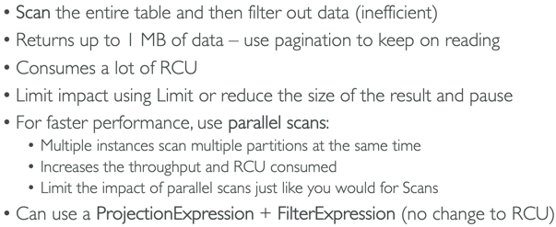

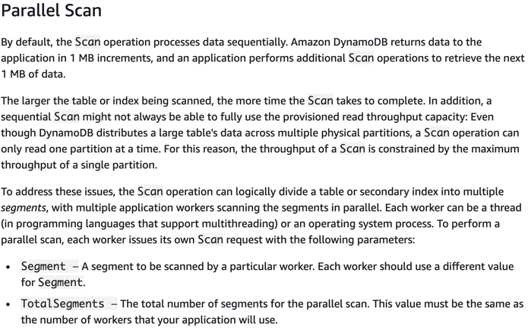

Backup DDB Table to S3

<https://aws.amazon.com/premiumsupport/knowledge-center/back-up-dynamodb-s3/>

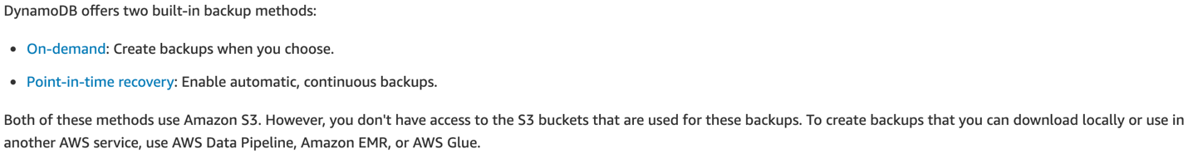

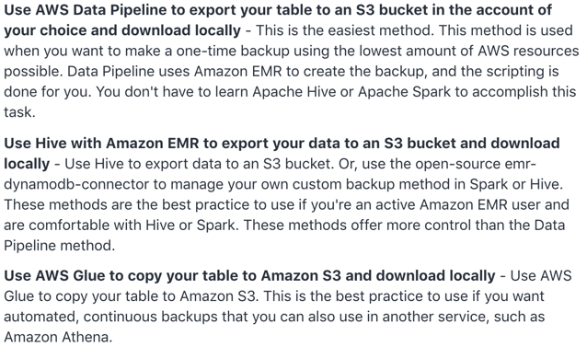

API Gateway

* Stages that point to versions, stage variables(passed to Lambda via Mapping Templates)
* Endpoint types – CF Edge, Region, Private
* Integration Types: Lambda, HTTP, Mock, AWS service
* TTL 0 – 300 – 3600sec
* Cache by STAGE; .5-237GB; flush/invalidate w/ header Cache-Control:max-age=0
* Throttling – 10k rps (set stage/method limits and Usage Plans/Keys); 5k in 1ms
* Sig v4 – put IAM credentials in header
* Websocket API – real time 2 way communication between browser and server
* CW logging at state level; error, debug, info
* CW Metrics – by stage, cache, latency, 4xx, 5xx
* 504 Gateway timeout after 29 sec
* CORS – Options pre flight request must contain following headers: Access-Control-Allow-<Methods, Headers, Origin>; A->B then apply to B the cross-origin
* Metrics – 4/5xxError, CacheHitCount, CacheMissCount, Count, Latency, IntegrationLatency

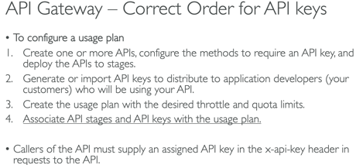

**API Gateway Authentication methods**:

1. IAM permissions with **sigv4** – add authentication info to AWS requests sent via HTTP
2. **Lambda Authorizer** is a CUSTOM Lambda function that you provide to control access to your API. It uses Bearer token authentication strategies which can be useful for 3rd party authentication; 2 types – token and request parameter based; you must first create the AWS Lambda function that implements the logic to authorize and if necessary authenticate the caller
3. Cognito User Pools

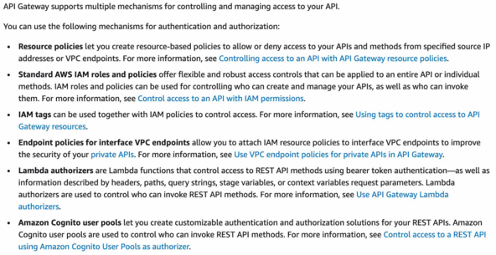

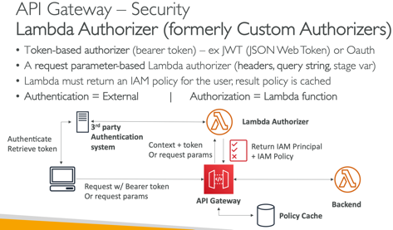 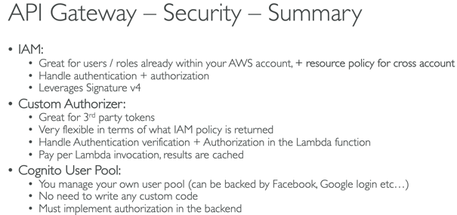

WAF

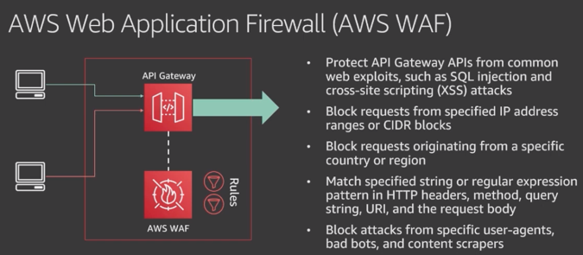

Cognito

User Groups – get token; API Gateway, ALB integration; invoke Lambda on events; customize UI w/CSS and logo; MFA

Identity Pools – get identity for users so they can obtain temp creds; unathenticated guest accounts

AppSync – sync across devices; offline mode; silent push sync; COG Stream; COG Event

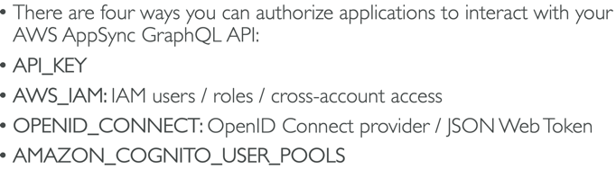

AWS AppSync simplifies application development by letting users create a flexible API to securely access, manipulate, and combine data from one or more data sources. AWS AppSync is a managed service that uses GraphQL to make it easy for applications to get the exact data they need. AWS AppSync allows users to build scalable applications, including those requiring real-time updates, on a range of data sources, including Amazon DynamoDB.

Step Function – state, max 1 yr; default – error causes execution to fail entirely; retry, catch; best practice – include data in error messages

SF code contains States, StartAt, Type:Task/Parallel, Resource, ResultPath, Next, Catch, ParallelProcessing

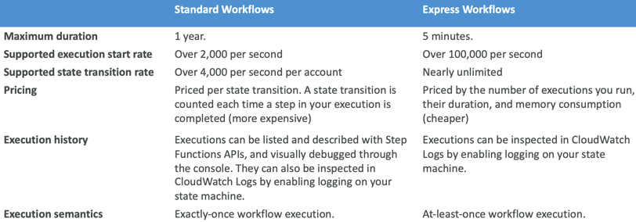

**Simple Workflow (SWF)** helps build, run and scale background jobs that have parallel or sequential steps. You can think of SWF as a fully managed state tracker and task coordinator.

Key Differences between SQS and SWF (Simple Workflow Service)

1. SWF ensures task is assigned only once while SQS may deliver message multiple times
2. SWF is task oriented API and SQS is message-oriented API

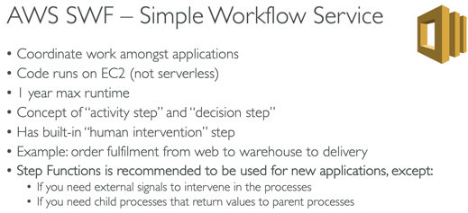 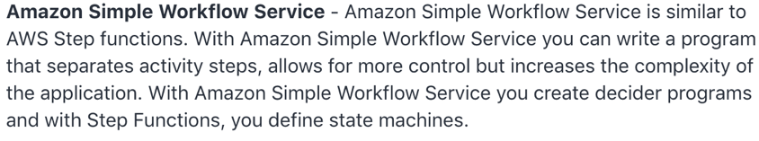

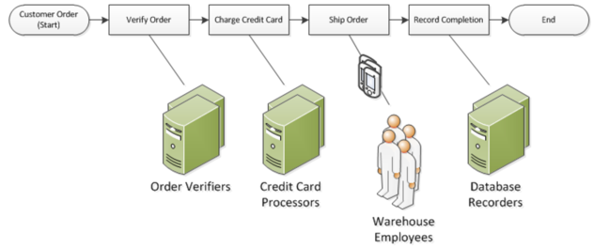

STS –AssumeRoleWithWebIdentity, AssumeRole (cross account 15min-1hr), GetSessionToken used for MFA(15min-12hr-36hr); page 651; on premise should use STS

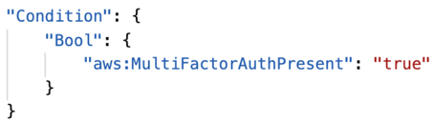 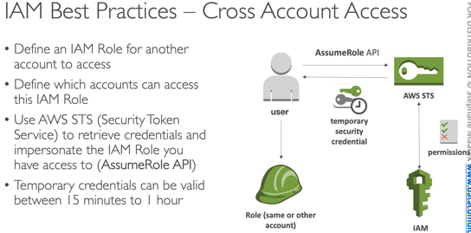 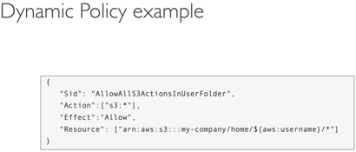

KMS – max 4KB data/call; **>4KB use envelope encryption w/GenerateDataKey api**; default policy – access to root user; custom policies; Encryption SDK; Data Key Caching - reuse data keys to limit KMS calls; Symmetric CMKs and Asymmetric private CMKs never leave KMS unencrypted

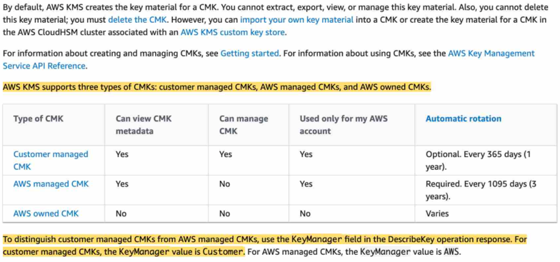

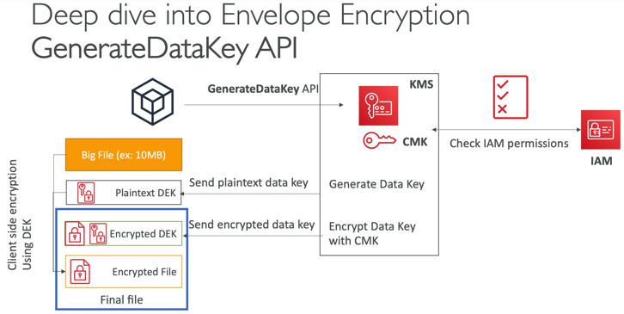 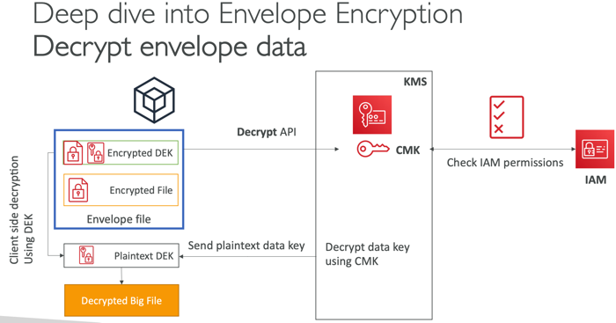

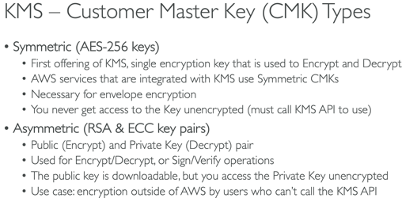 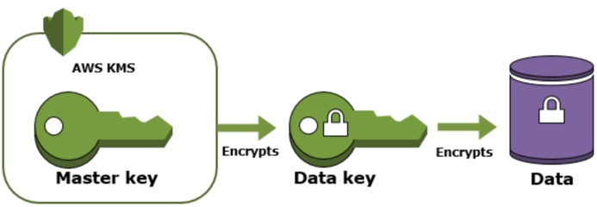

Snapshots/Encrypted Volumes



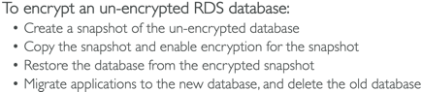 (as of 2019 reinvent you can check encrypt when creating a volume from a snapshot)

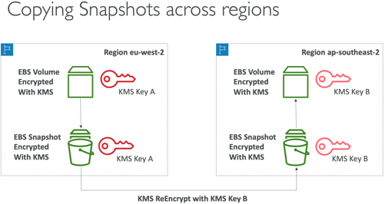 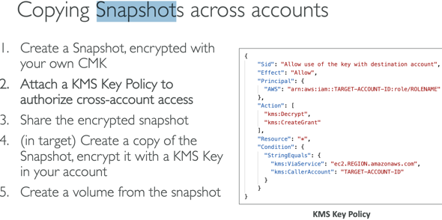

(as of 2019 you can share encrypted snapshots across accounts)

**AWS Config** – records the state of your AWS environment and can notify you of changes; resource specific history, audit and compliance; review changes in configurations and relationships between AWS resources, dive into detailed resource configuration histories, and determine your overall compliance against the configurations specified in your internal guidelines

SSM – version secrets; TTL policies; GetParameters, GetParametersByPath; KMS optional; SecureString parameters

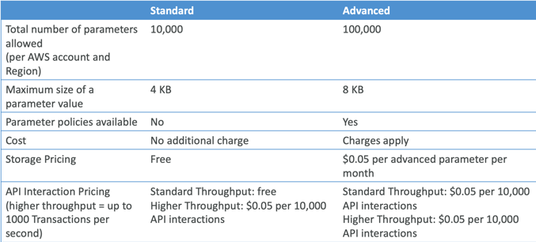

Secrets Manager – **rotation**, costly, mostly meant for RDS, KMS encryption mandatory

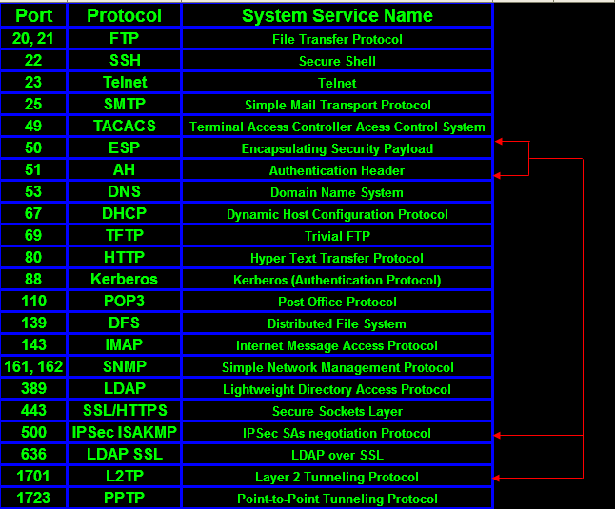

**API Functions:**

**XRay** – PutTraceSegments, PutTelemetryRecords, GetSamplingRules, GetSamplingTargets, GetServiceGraph, BatchGetTraces, GetTraceSummaries, GetTraceGraph

**SQS** – CreateQueue, DeleteQueue, SendMessage, ReceiveMessage, DeleteMessage, ChangeMessageVisibility, PurgeQueue, ReceiveMessageWaitTimeSeconds (Long Poll)

**DynamoDB** – PutItem, UpdateItem, DeleteItem, DeleteTable, BatchWriteItem(max 25 items), GetItem, BatchGetItem(max 100)

**KMS** – Encrypt, Decrypt, Reencrypt, GenerateDataKey, GenerateDataKeyWithoutPlaintext, GenerateRandom, (Sign, Verify – asymmetric)

**STS** - decode-authorization-message, AssumeRoleWithWebIdentity, AssumeRole (cross account 15min-1hr), GetSessionToken(15min-12hr-36hr)

**SSM** – GetParameters(ByPath)

**Kinesis** – PutRecord

**CloudWatch** – CreateLogGroup, CreateLogStream, PutLogEvents, PutMetricData, GetMetricStatistics

**EC2** - DescribeInstances

Intrinsic Functions: Ref – reference parameter/resource; GetAtt, FindInMap, ImportValue, Join, Sub

(**!FindInMap [ MapName, TopLevelKey, SecondLevelKey ]**)

IAM – Global

EBS, Subnet, ENIs – AZ

EC2, AMI, S3, EFS, Security Groups, ELB, ASG, KMS keys, Snapshot, VPC, Lambda, API – Region

REVIEW: VPC, ECS/ECR, Lambda Event Source Mapping, Lambda Mapper Scaling

SDK – when to use

Reinvent –

ASG - <https://www.youtube.com/watch?v=9BlsFNBnKHc>

IAM - <https://www.youtube.com/watch?v=YQsK4MtsELU>

ELB - <https://www.youtube.com/watch?v=VIgAT7vjol8>

EBS - <https://www.youtube.com/watch?v=wsMWANWNoqQ>

EC2 – <https://www.youtube.com/watch?v=kMMybKqC2Y0>

VPC - <https://www.youtube.com/watch?v=jZAvKgqlrjY>

ECS - <https://www.youtube.com/watch?v=mUzsYt3Bj08>

Beanstalk - <https://www.youtube.com/watch?v=o4clRJuH9xU&t=2740s>

Cloudformation - <https://www.youtube.com/watch?v=bJHHQM7GGro>

Messaging(SQS, Kinesis, SNS) - <https://www.youtube.com/watch?v=4-JmX6MIDDI>

DynamoDB - <https://www.youtube.com/watch?v=HaEPXoXVf2k>

API Gateway - <https://www.youtube.com/watch?v=cc_pKfDOH2E>

If you continue to use the root account then use MFA

By default, IAM users do not have access to the AWS Billing and Cost Management console. You or your account administrator must grant users access. You can do this by activating IAM user access to the Billing and Cost Management console and attaching an IAM policy to your users. Then, you need to activate IAM user access for IAM policies to take effect. You only need to activate IAM user access once.

AWS Budgets lets customers set custom budgets and receive alerts if their costs or usage exceed (or are forecasted to exceed) their budgeted amount.

AWS requires approximately 5 weeks of usage data to generate budget forecasts. If you set a budget to alert based on a forecasted amount, this budget alert isn't triggered until you have enough historical usage information.

T2 micro free during first 12 months

EC2 key pairs used for SSH; you can generate a public key from a private key and store the public key in multiple regions

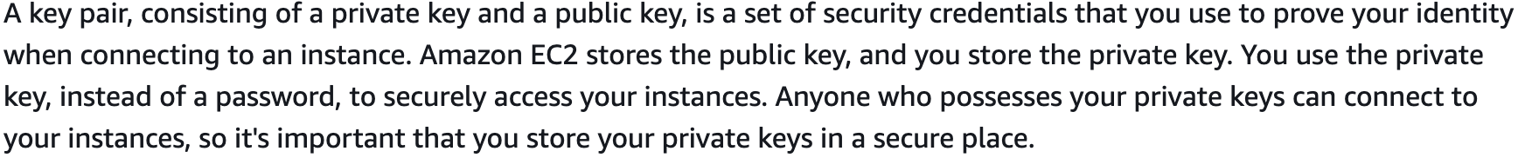

Cloudfront key pairs – must use root credentials to create

CLI/API – access keys

Aws configure

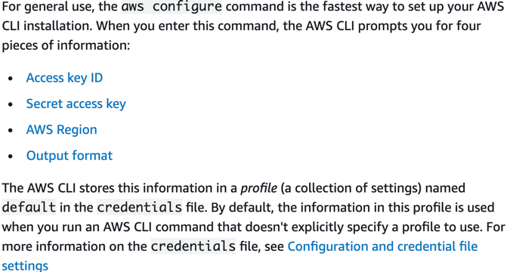

SMS-based MFA is available only for IAM users, you cannot use this type of MFA with the AWS account root user

MFA – Hardware, virtual, U2F

1GB = 1000MB; 1MB = 1000 KB

If you want to execute a command (for example to stop an EC2 instance) then you must be in your default region; if not then use the --region parameter to set it

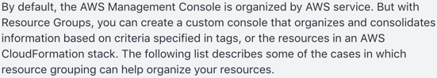

Errors

* 503 – service unavailable, at capacity or no registered target; 504 gateway timeout
* 429 – too many requests; 401 - unauthorized

Use SDK to perform actions on AWS directly from your applications code

<https://d1.awsstatic.com/training-and-certification/docs-dev-associate/AWS-Certified-Developer-Associate_Sample-Questions.pdf>

<https://d1.awsstatic.com/training-and-certification/docs-dev-associate/AWS_certified_developer_associate_examsample.pdf>